**Title of the project :** Making a human following robot by using Arduino UNO.

**Introduction and Motivation :** Human following is a technique used by robot and autonomous vehicles to follow a human within a specific range. In this case, communication between the human and the robot is the most significant factor where sensor is needed to ensure its successfulness. The basic function of this robot is simple: it follows you. It goes forward as you go forward; when you stop moving, it stops as well.We used an Arduino UNO to identify the moving direction of the object. You can also add more number.

The main motivation behind this project is to reduce human labour. The human following robot reduce the human effort in carrying their goods while shopping.It can also be used in daily activists as an attendant which will help us by carrying our necessary things and moved with us by following us.

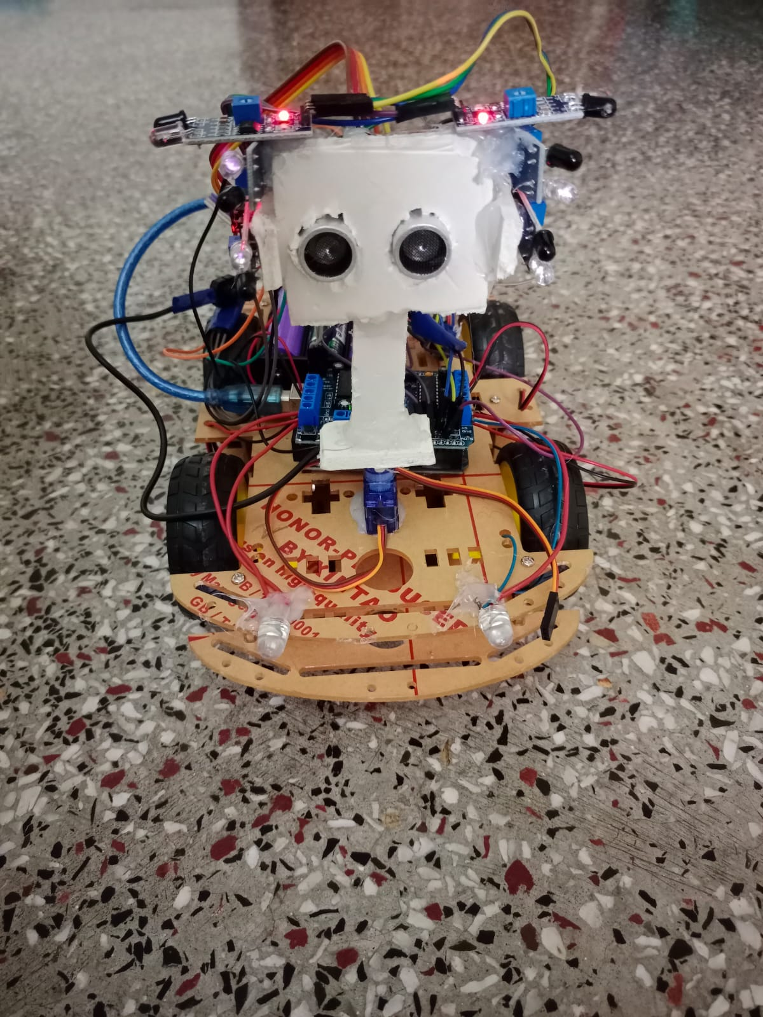

Figure: Human Follower Robot

**Literature Review :** K. Morioka, J-H. Lee, and H. Hashimoto,―Human-following mobile robot in a distributed intelligent sensor network,‖ Some other research work was also conducted In this regard, Depth imaging was used by Calisi and the Target was pursued by designing a special algorithm .They did a lot of work on object tracking and detection. The biggest advantage of their method was that their algorithm worked in complex environments as well [1]

J. H. Lee, T. Tsubouchi, K. Yamamoto,and S. Egawa, ―People Tracking Using a Robot in Motion with Laser Range Finder,‖ and M.Lindstrom and J. O. Eklundh, ―Detecting And tracking moving objects from a mobile platform using a laser range scanner‖, Different algorithms are being developed by the researchers for the detection purposes. Laser was used in one research to find the style of the moving legs and a camera was used to detect a object or a person. A very simple technique was also used by researchers. In this technique, the person used distance sensors on the robot and the person. These sensors emitted radio waves and were detected by the sensors on the person to be followed. This way the robot followed the required target.[2]

Later on,Leo Louis in his paper, ‖Working Principle of Arduino and using it as a tool for study and research‖ tells us that Arduino is a open source microcontroller which can be easily programmed erased and reprogrammed at any instant of time.The Current advanced uses of Arduino also include: Arduino AutoBilling Shopping Trolley,Arduino Fire Detector & Extinguisher Bot, IR Vision Snake Robot-Arduino.[3]

Methodology:

Circuit diagram of a human following robot :

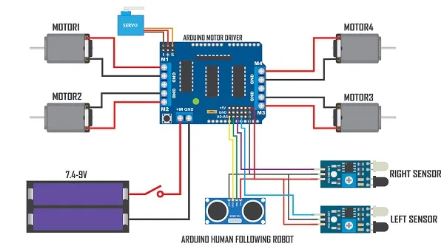

**Components:**

1) Arduino Uno

2) Motor Driver Shield

3) Wheels (4x)

4) TT Gear Motor (4x)

5) Servo Motor

6) Car Chassis

7) Ultrasonic Sensor

8) Infrared Sensor (2x)

9)18650 Li-on Battery (2x)

10) 18650 Battery Holder

11) Male and Female Jumper wire

12) DC Power Switch

**Main purpose of the project**:

Human following robot is very common in this technology era. Human following is a technique used by robot and autonomous vehicles to follow a human within a specific range. In this case, communication between the human and the robot is the most significant factor where sensor is needed to ensure its successfulness.

**Working procedure:**

After completing all the stuff according to this connection format, the Human Follower Robot performing as expected. It will dectect any object within its 2 cm to 200 cm range by ultrasonic sensor. This will enable the Human Follower Robot to move forward. The IR sensor will help to move the Human Follower Robot to move left side ,right side or backward according to the object movement within it’s range between 2 cm to 30 cm.

**Discussion** :

This experiment to see if the robot kept a certain distance from the target object. Then we performed the test to check whether the robot maintains a specific distance with the target object. We also will be tested intermittent interactions between Arduino, motor guard, and colored motors. Based on the results obtained from these tests and tests, we have made the necessary changes to the processing and control algorithm. The main difficult thing about this is building an algorithm on which the working behaviour of this robot depends. So, the main object of this phase is to understand the algorithm and the connection diagram. In this project, the human following robot has been made to follow the human. This robot has an ultrasonic sensor which detects the object and sends the information to the Arduino and motor driver which control the process of the wheels and microcontroller controls the whole operation. The human following robot will be lastly finished.

**Conclusion :**

A successful implementation of a person follower robot is illustrated.This robot does not only have the detection capability but also the tracking and following ability as well. The tracking is basically performed on the tag and the human is followed on the basis of that detection. It was also kept in mind that the following capability of the robot should be as efficient as possible. The tests were performed on the different conditions to pin point the mistakes in the algorithm and correct them. The different sensors that were integrated with the robot added an additional advantage.

**Applications:**

1.The human following robot can use in the defense sector also to carry weapons for the soldiers.

2. The human following robot is an automobile system that has ability to recognize obstacle, move and change the robot's position toward the subject in the best way to remain on its track.